**The CRAAP Test**

The CRAAP Test is an evaluation method that was designed by librarian Sarah Blakeslee at the Meriam Library California State University, Chico. CRAAP stands for Currency, Relevance, Authority, Accuracy and Purpose. This provides you with a method and list of questions to evaluate the nature and value of the information that you find.

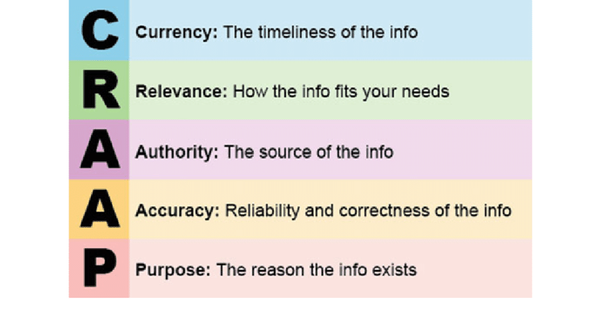

**C - Currency**

**The timeliness of the information:**

When was the information published or posted?  
Has the information been revised or updated?  
Does your topic require current information, or will older sources work as well?  
Are the links functional?

**R - Relevance**

**The importance of the information for your needs:**

Does the information relate to your topic or answer your question?  
Who is the intended audience?  
Is the information at an appropriate level (i.e. not too elementary or advanced for your needs)?  
Have you looked at a variety of sources before determining this is one you will use?  
Would you be comfortable citing this source in your research paper?

**A - Authority**

**The source of the information:**

Who is the author/publisher/source/sponsor?  
What are the author's credentials or organizational affiliations?  
Is the author qualified to write on the topic?  
Is there contact information, such as a publisher or email address?  
Does the URL reveal anything about the author or source?

.ac.uk = Academic institutions in the UK  
.com = Commercial sites  
.edu = Educational institutions  
.gov = Government  
.nhs.uk = Health information services in the UK  
.org = Non-profit organizations  
.mil = Military  
.net = Network.

**A - Accuracy**

**The reliability, truthfulness, and correctness of the content:**

Where does the information come from?  
Is the information supported by evidence?  
Has the information been reviewed or refereed?  
Can you verify any of the information in another source or from personal knowledge?  
Does the language or tone seem unbiased and free of emotion?  
Are there spelling, grammar or typographical errors?

**P - Purpose**

**The reason the information exists:**

What is the purpose of the information? Is it to inform, teach, sell, entertain or persuade?  
Do the authors/sponsors make their intentions or purpose clear?  
Is the information fact, opinion or propaganda?  
Does the point of view appear objective and impartial?  
Are there political, ideological, cultural, religious, institutional or personal biases?

Citation:

University of Chicago Library. (n.d.). *Chicago style guide: Notes and bibliography style—General guidelines*. <https://guides.lib.uchicago.edu/c.php?g=1241077&p=9082343>